GNAO AOB Project Update
Project Manager: [name]
Project Assistant / Coordinator: [name]
[Date]

Schedule | Scope
[Summarize schedule progress.] | [Summarize scope status. Have there been any change requests?]
Resources | Risks
[Summarize any resource issues.] | [Summarize risk status.]
[Color code title box using the paint bucket icon in the menu bar: green (OK), yellow (caution), or red (critical) depending on the status. Note that the overall risk status should correspond to the total project risk per the project risk register.

Project Report Summary
[Provide a brief summary of your project’s progress.]

Technical Status

[Information regarding the technical status of the Work overall, and in each engineering discipline; The report should include what was accomplished last month and what is planned for the next month, as well as a comparison of the work done with respect to the work originally planned. The report should include the work of major subcontractors. Contractor should also include Key Performance Metrics including the requirement, current best estimate, and the current margin. Contractor shall retain and present the entire log of previous monthly values for comparison]

Project Management Status

Schedule Management

[ Include an updated schedule consisting of the most current project plan to completion. Contractor shall compare the current schedule to the last approved baseline schedule and to the original approved baseline schedule. Contractor shall maintain the schedule in Microsoft Project, or equivalent (Excel format is not acceptable), and present it in this monthly report as a Gantt chart including a column showing percent complete for each listed task. Contractor shall report the current expected project completion date, including its associated margin and uncertainty;]

Cost Management

[ Include the following:

Table of financial data comparing: (See example table below)

Contract value (i.e. total approved budget)

Stage budget (approved budget of current stage)

Contract spend to date

Stage spend to date

Open Commitments

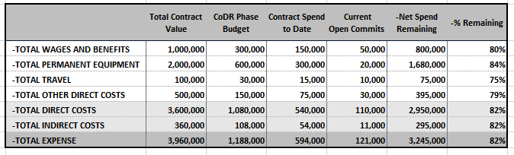

Total dollar values of invoices

Payments received to date

Estimate of Total Project Cost to Completion, presented as a 3-point estimate, summarized by budget per fiscal year through the end of the contract.

Estimate of Cost to Stage Completion

Costed list of risks and connection with estimates to project and stage completion

Schedule Performance Index

[SPI = Earned Value (EV) / Planned Value (PV) )],

Cost Performance Index

[CPI =Earned Value (EV) / Actual Cost (AC)]

Mitigation and restoration plans for CPI and SPI numbers falling outside of the 0.9 - 1.1 range.]

Milestones
[A table of the major milestones, and cross-institute deliverables, with the original, previous, and current dates by which they will be attained. Contractor shall explain any significant changes from the previous date and include all the explanations from previous lists]

WBS# | Description | Original Completion Date | Current Completion Date | Comment
[add as many rows as needed]

Issues and Risks Summary
[Issues and problem areas related to the Work, including potential for delays, risk mitigation plans, and the status of identified risks]

Issue/Risk | Risk Level | Mitigation
[add as many rows as needed]

Action Items
[High-level action items for Gemini and Contractor (both open and closed), and associated status. Contractor shall be responsible for recording and tracking the high-level action items.]

Action Item | Responsible | Comments | Status (Open/Closed)

